Sl No |  | Name |  | Designation |  | Photo
1. |  | Dr. Milan Kumar Chauley |  | Superintending Archaeologist |  | 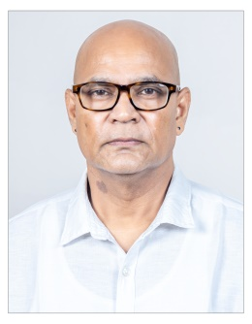
2. |  | Sh. Chittaranjan Dash |  | Deputy Superintending Archaeological Engineer |  | 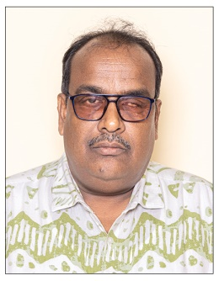
3. |  | Dr. P. P. Pradhan |  | Assistant Superintending Archaeologist |  | 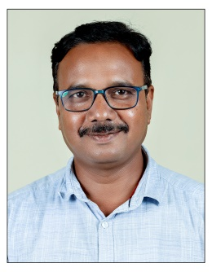
4. |  | Dr. Tikam Tenwar |  | Assistant Superintending Archaeologist |  | 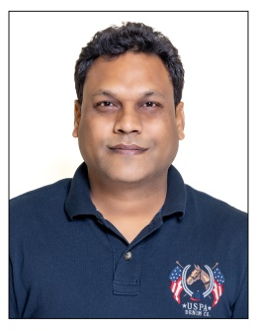
5. |  | Sh. Sudipta Sen |  | Assistant Superintending Archaeological Engineer |  | 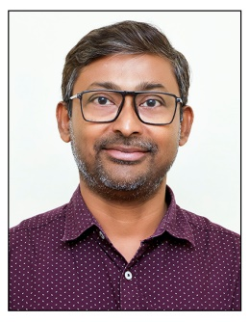
6. |  | Sh. P.K. Prusty |  | Junior Administrative Officer |  | 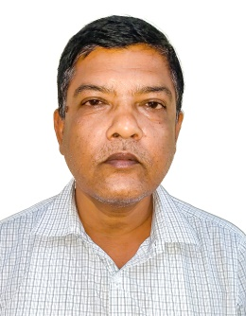
Sl No | Name of the Ticketed Monument/Museum |  | Offline ticket Price |  | Online/Card ticket price |  | QR Code
1. | Sun Temple, Konark |  | Indians - Rs. 40/-  Foreigners – Rs. 600/- |  | Indians –  Rs. 35/-  Foreigners – Rs. 550/-
2. | Archaeological Museum, Konark |  | Indians - Rs. 10/-  Foreigners – Rs. 10/- |  | Indians - Rs. 10/-  Foreigners – Rs. 10/-
3. | Buddhist Site, Ratnagiri |  | Indians - Rs. 25/-  Foreigners – Rs. 300/- |  | Indians - Rs. 20/-  Foreigners – Rs. 250/-
4. | Archaeological Museum, Ratnagiri |  | Indians - Rs. 5/-  Foreigners – Rs. 5/- |  | Indians - Rs. 5/-  Foreigners – Rs. 5/-
5. | Buddhist Site, Lalitagiri |  | Indians - Rs. 25/-  Foreigners – Rs. 300/- |  | Indians - Rs. 20/-  Foreigners – Rs. 250/-

